

**Lab # 03**

**Student Name: Piyar Ali Soomro**

**Roll Number: BIT-23F-019**

**Section: A**

**Subject: Artificial Intelligence**

**Department: BS Information Technology**

**Objective: To get Familiar with Logical operators and Conditional Structure and Loops**

1. Introduction to Logical Types:

Logical types in Python represent truth values. The two logical types in Python are `True` and `False`, which are instances of the `bool` class.

1. Boolean Operators:
   1. **And: Returns true if both operands are true.**
   2. **OR: Returns true if either operand is true.**
   3. **Nott: Returns the opposite Boolean value of the operand.**

Boolean Operations Example

x = True

y = False

print(x and y) # Output: False

print(x or y) # Output: True

print(not x) # Output: False

1. Conditional Statements:

if, ELIF, AND ELSE STATEMENTS:

Conditional statements allow us to execute different blocks of code based on certain conditions.

Conditional Statements Example

age = 20

if age < 18:

print("You are a minor.")

elif age >= 18 and age < 65:

print("You are an adult.")

else:

print("You are a senior citizen.")

**Assignments**

### Lab Task 1: Simple ATM Machine Create a simple ATM program where the user has to enter a PIN to proceed.

* The correct PIN should be 1234.
* If the user enters the correct PIN, display a menu that allows the user to:
  + **Check Balance** (display a fixed balance, e.g., 1000).
  + **Withdraw Money** (ask the user how much they want to withdraw and deduct that amount from the balance).
* If the user enters an incorrect PIN, print "Incorrect PIN" and terminate the program.

**Lab Task 2:** Write a program that asks the user to enter a **username** and **password**.

* The correct username should be "admin" and the correct password should be the **numeric value** 12345.
* If both the username and password are correct, the program should display "Login Successful!".
* If the username is incorrect, display "Incorrect username".
* If the password is incorrect, display "Incorrect password".

### Lab Task 01 :

### Simple ATM Machine Create a simple ATM program where the user has to enter a PIN to proceed.

* The correct PIN should be 1234.
* If the user enters the correct PIN, display a menu that allows the user to:
  + **Check Balance** (display a fixed balance, e.g., 1000).
  + **Withdraw Money** (ask the user how much they want to withdraw and deduct that amount from the balance).
* If the user enters an incorrect PIN, print "Incorrect PIN" and terminate the program.

**Code:**

# ATM Machine Program

# Initial balance

balance = 1000

# Correct PIN

correct_pin = 1234

# Function to display the menu

def atm_menu():

    print("Aslamo-ul-kum :")

    print("WELCOME TO ATM MASHINE:")

    print("\nATM Menu:")

    print("1. Check Balance")

    print("2. Withdraw Money")

    print("3. Exit")

# Function to check balance

def check_balance():

    print(f"\nYour current balance is: ${balance}")

# Function to withdraw money

def withdraw_money():

    global balance

    amount = float(input("\n Piyar Ali please Enter the amount to withdraw: "))

    if amount <= balance:

        balance -= amount

        print(f"${amount} withdrawn.Now your remaining balance is : ${balance}")

    else:

        print("Insufficient balance!")

# Main program logic

def atm():

    # User enters PIN

    pin = int(input("Enter your PIN: "))

    # Check if the PIN is correct

    if pin == correct_pin:

        while True:

            atm_menu()

            choice = input("\n Please Choose an option of the following: ")

            if choice == '1':

                check_balance()

            elif choice == '2':

                withdraw_money()

            elif choice == '3':

                print("Exiting the ATM. Thank you!")

                break

            else:

                print("Invalid option. Please try again.")

    else:

        print("Incorrect PIN. Terminating program.")

# Run the ATM program

atm()

**Output: 1: Check balance:**

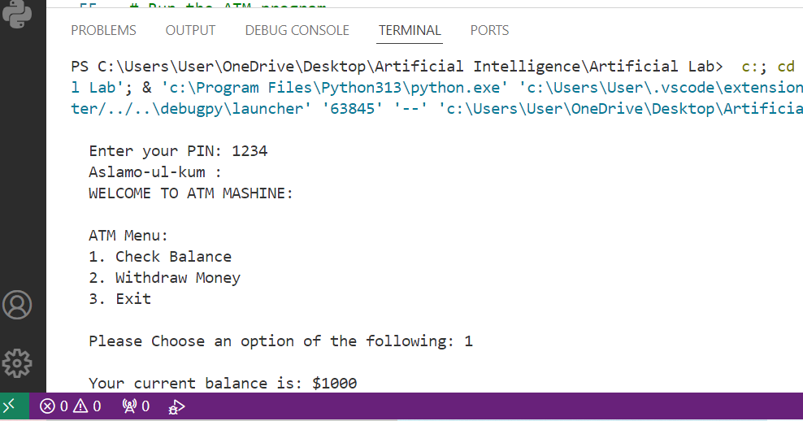

**2: Withdraw money:**

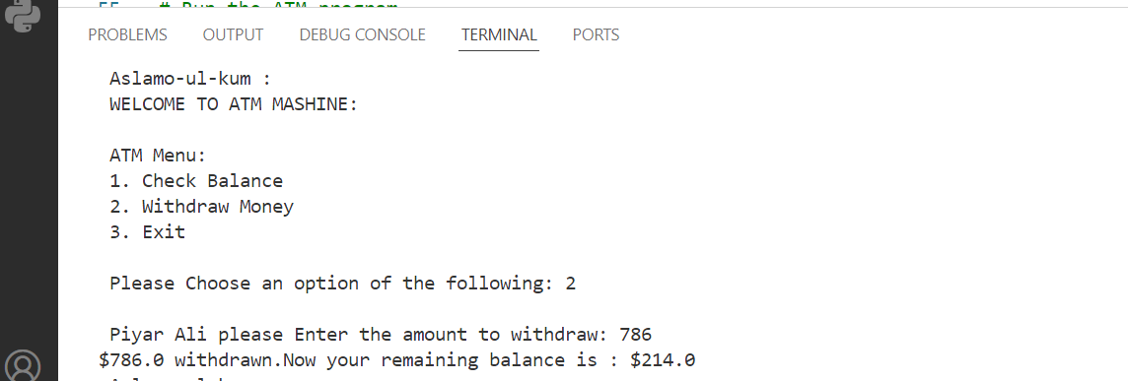

**3: Exit:**

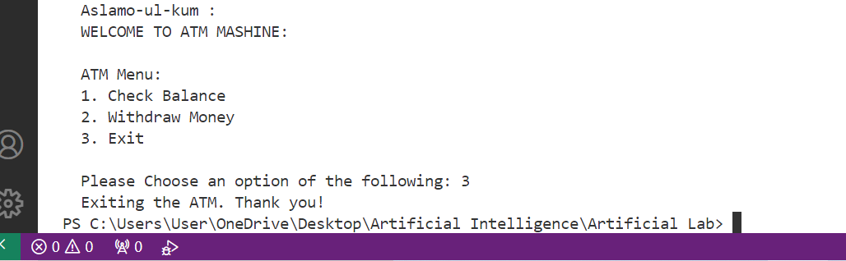

**Lab Task 2:**

Write a program that asks the user to enter a **username** and **password**.

* The correct username should be "admin" and the correct password should be the **numeric value** 12345.
* If both the username and password are correct, the program should display "Login Successful!".
* If the username is incorrect, display "Incorrect username".
* If the password is incorrect, display "Incorrect password".

**Code:**

# Program to check username and password

# Set the correct username and password

correct_username = "admin"

correct_password = 12345

# Ask the user to enter the username and password

username = input(" \n Hello Comrade Enter User Name: ")

password = input(" Enter password: ")

# Check if both username and password are correct

if username == correct_username and password == str(correct_password):

    print(" congratulation Login Successful!")

# Check if the username is incorrect

elif username != correct_username:

    print("Incorrect username")

# Check if the password is incorrect

elif password != str(correct_password):

    print("Incorrect password")

**output:**

**Login Successful!**

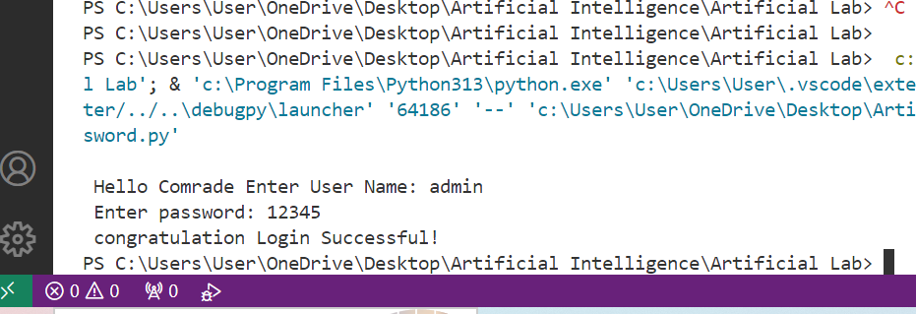

**Incorrect username:**

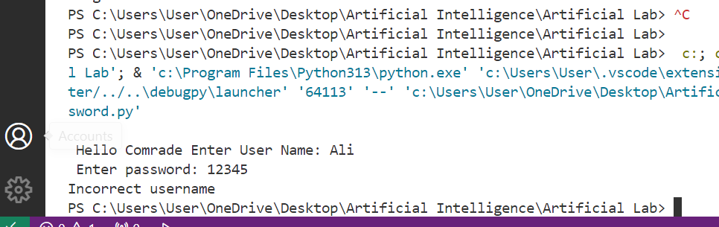

**Incorrect password:**

